** EAST WEST UNIVERSITY**

**Experiment No:** 05

**Course Code:** ICE470

**Course Title:** Numerical Method Lab

**Experiment Name:** Root Finding using Gauss Seidel.

**Submitted To:**

Mr. Rasel Ahmmed  
 Lecturer, Department of ECE

**Submitted by:**

Md. Tariqul Islam  
**ID NO:** 2014-2-50-021

**Date of Performance**: 05.07.2018

**Date of Submission:** 19.07.2018

**Experiment No: 05**

**Experiment Name:** Root Finding using Gauss Seidel.

**Objective:**

**1.** To find out the root through gauss seidel.

**2.** To compare the real and estimated error.

**1. Matlab Code :**

clc

close all

clear all

A = input ('enter the value A :');

b = input('enter the value B :');

Ab = [A b];

%Rearrange to get diagonally dominat matrix

%3->1->2

Ad = [Ab(3,:);Ab(1,:); Ab(2,:);];

n = 3; %n = no of equations

x = [0.1; 0.1; 0.1]; %initial guess

pst = 0.01; %pre-specified tolerance

% Gauss Seial method

fori = 1:100 %maximum no of iteration

for r =1:n

xold = x(r);

nu = Ad(r,end)-Ad(r,1:r-1)*x(1:r-1)-Ad(r,r+1:n)*x(r+1:n);

de = Ad(r,r);

x(r) = nu/de; %new x(r)

error(r) = abs((x(r)-xold)*100/x(r));

end

ermax = error(1); %maximum error

for r=1:n

if (ermax<=error(r))

ermax=error(r);

end

end

fprintf('approximate error is =%f''\n',ermax);

if (ermax<pst)

break;

end

end

fprintf('\n');

fprintf('The root of the system using Gauss seidal method:x1 = %f''\n',x(1));

fprintf('The root of the system using Gauss seidal method:x2 = %f''\n',x(2));

fprintf('The root of the system using Gauss seidal method:x3 = %f''\n',x(3));

fprintf('Number of iteration = %f''\n',i);

fprintf('approximate error = %f''\n',ermax);

%plot

symsx1x2x3

ezsurf((3-2*x1-6*x2)/(-2)),[15,-15];

hold on

ezsurf((2+2*x1-x2)/(5)),[15,-15];

hold on

ezsurf((3-4*x1-x2)/(1)),[15,-15];

hold on

**Command Window :**

enter the value A :[2 6 -2;-2 1 5; 4 1 1];

enter the value B :[3; 2; 3]

approximate error is =85.714286'

approximate error is =43.750000'

approximate error is =5.960265'

approximate error is =1.772624'

approximate error is =0.295536'

approximate error is =0.060493'

approximate error is =0.010082'

approximate error is =0.001457'

The root of the system using Gauss seidal method:x1 = 0.500002'

The root of the system using Gauss seidal method:x2 = 0.499999'

The root of the system using Gauss seidal method:x3 = 0.500001'

Number of iteration = 8.000000'

approximate error = 0.001457'

**Figure 1 :**

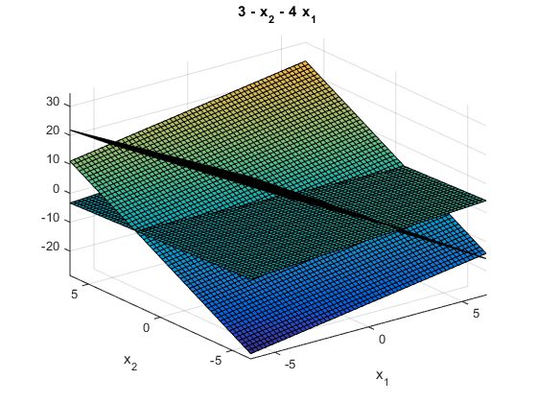

**2. Matlab Code (Practice) :**

clc

close all

clear all

A = input ('enter the value A :');

b = input('enter the value B :');

Ab = [A b];

%Rearrange to get diagonally dominat matrix

%3->1->2

Ad = [Ab(1,:);Ab(2,:); Ab(3,:);];

n = 3; %n = no of equations

x = [0.1; 0.1; 0.1]; %initial guess

pst = 0.01; %pre-specified tolerance

% Gauss Seial method

fori = 1:100 %maximum no of iteration

for r =1:n

xold = x(r);

nu = Ad(r,end)-Ad(r,1:r-1)*x(1:r-1)-Ad(r,r+1:n)*x(r+1:n);

de = Ad(r,r);

x(r) = nu/de; %new x(r)

error(r) = abs((x(r)-xold)*100/x(r));

end

ermax = error(1); %maximum error

for r=1:n

if (ermax<=error(r))

ermax=error(r);

end

end

fprintf('approximate error is =%f''\n',ermax);

if (ermax<pst)

break;

end

end

fprintf('\n');

fprintf('The root of the system using Gauss seidal method:x1 = %f''\n',x(1));

fprintf('The root of the system using Gauss seidal method:x2 = %f''\n',x(2));

fprintf('The root of the system using Gauss seidal method:x3 = %f''\n',x(3));

fprintf('Number of iteration = %f''\n',i);

fprintf('approximate error = %f''\n',ermax);

%plot

symsx1x2x3

ezsurf((3-4*x1+x2)/(-1)),[15,-15];

hold on

ezsurf((9+2*x1-6*x2)/(1)),[15,-15];

hold on

ezsurf((-6+x1-x2)/(7)),[15,-15];

hold on

**Command Window :**

enter the value A :[4 -1 -1; -2 6 1; -1 1 7]

enter the value B :[3; 9; -6]

approximate error is =110.071942'

approximate error is =14.828897'

approximate error is =5.432130'

approximate error is =0.623960'

approximate error is =0.049552'

approximate error is =0.002777'

The root of the system using Gauss seidal method:x1 = 0.999999'

The root of the system using Gauss seidal method:x2 = 2.000001'

The root of the system using Gauss seidal method:x3 = -1.000000'

Number of iteration = 6.000000'

approximate error = 0.002777'

**Figure 2:   
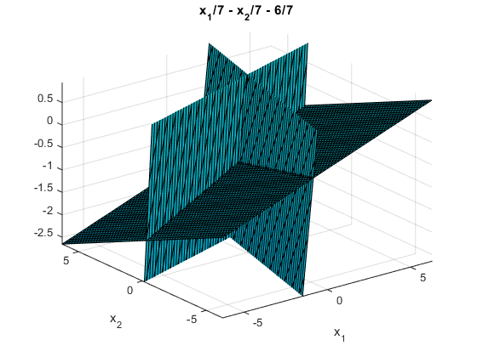  
  
  
Discussion:** This experiment name is Root Finding using Gauss Seidel. Gauss Seidel is one of the numerical techniques for solving linear equations. There are two program codes. The 1st one program code was given as lab manual and the 2nd program code was done as practice program code. In the 1st program code, the value of A and b has to be given as a user input. In the coommand window after entering the value of A and b approximate error, root of the system for x1, x2,x3 and number of iteration all the value has been defined. Given equation,

2x+6y-2z= 3 ---(i)

-2x+y+5z= 2 ---(ii)

4x+y+z= 3 ---(iii)

In this method the computations need to be appear in serial because |2|>|6|+|-2|=8; 2 is less then 8. The new equation according Gauss Seidel method,

4x+y+z= 3 ---(i)

2x+6y-2z= 3 ---(ii)

-2x+y+5z= 2 ---(iii)  
After running the program code, putting the values of A and b then there comes a figure for the 1st program code which shows 3-D colored surface plotter because in the program code there is a function named ezsurf. There is one more function which is hold on that means retains the current plot and certain axes properties so that subsequent graphing commands add to the existing graph. If I don’t write the function hold on in the program code then the full figure of the colored surface will see as one surface not like the three surfaces as now looking in the figure 1.   
The practice program code is same as the first program code. For the second program code the given equation,

4x-y-z= 3 ----- (i)

-2x+6y+z= 2 ----- (ii)

-x+y+7z= -6 ----- (iii)

This equation serial doesn’t need to be change because |4|>|-1|+|-1|=2; 4 is greater then 2. So, the equation serial remains same as preivious. After putting the value of A and b as a user. then get to know the value of approximate error, root of the system for x1, x2,x3 and number of iteration. For this program code there is also a figure. This code is easy to perform but need to be attentive while doing codes and have to know about Gauss Seidel correctly otherwise there will be problem in writing codes.